**Linux commands**

1. **Uname:**

Uname prints the kernel name.

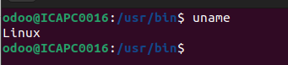

1. **whoami:**

Whoami prints the username of the system.

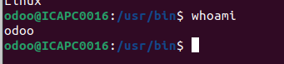

1. **cd:**

With the help of cd we can change or open any folder

With cd .. we can exit the current folder

Example : cd <dir_name>

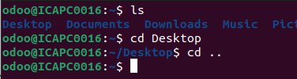

1. **pwd:**

Pwd stands for print working directory. It is print the whole path of working directory.

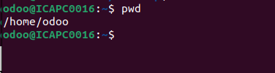

1. **ls:**

Ls command used to print the all directories and files in current directory.

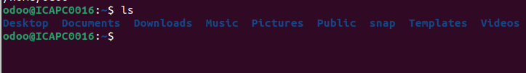

Ls -a option prints all directories and files including hidden files.

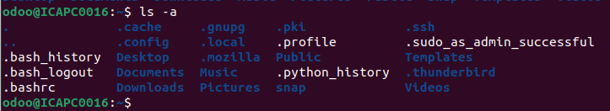

Ls -l it is print the long format of listed directories.

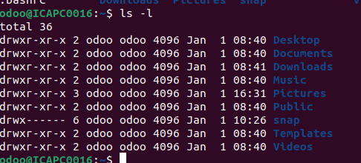

1. **clear:**

Clear command used for clear terminal.

1. **cp:**

Cp command used to copy file.

Example: cp <source_file> <destination_file>

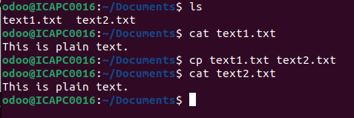

1. **cat:**

Cat command used to the create file and add content to them.

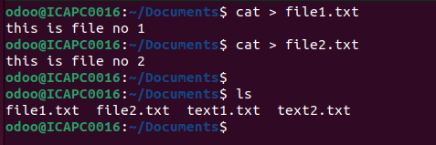

Cat command also used for display content of the file.

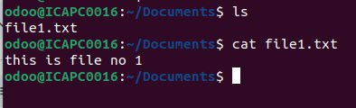

1. **Head:**

Head command used to print first n number bytes or lines of the file.

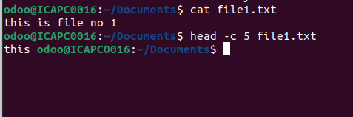

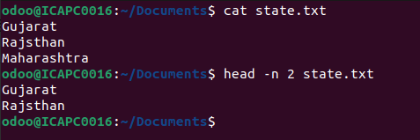

1. **tail:**

Tail command used to print last ten lines of he file.

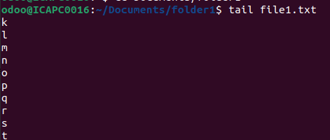

1. **mv:**

Mv command used for moving file or directory.

Example: mv <source_file> <destination_file>

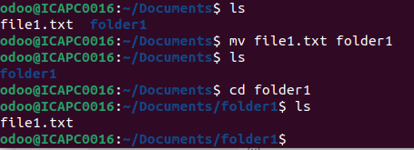

1. **Touch:**

Touch command used for creating empty files.

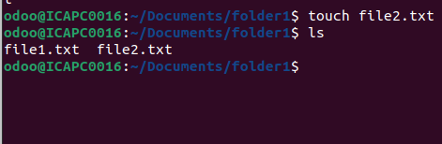

1. **mkdir:**

Mkdir command used to create or making directories

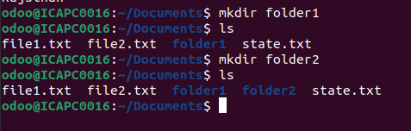

1. **rm:**

Rm command used to remove file.

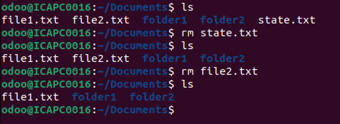

1. **rmdir:**

Rmdir command used for remove directory.

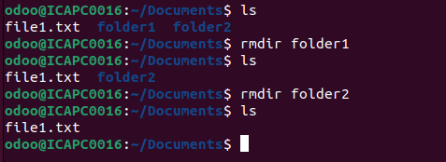

1. **Ps:**

Ps command stand for process status. Which is used for view running processes.

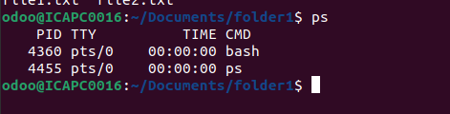

List of all running Process: Command: ps -aux

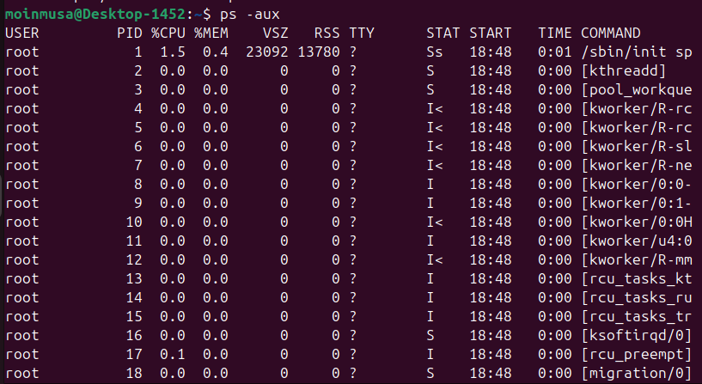

List processes for a specific user: Command: ps -u user_name

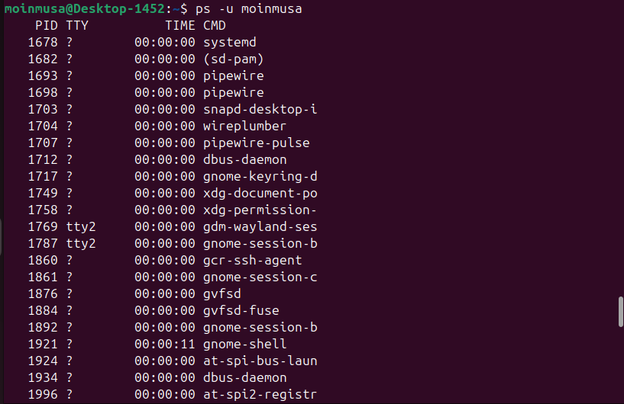

1. **kill:**

Kill command used for terminating processes manually.

Kill a specific process:

Command: kill PID



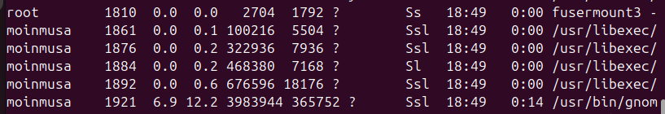

Stop a process: Use the pkill command with the process name. The basic syntax is pkill process_name. Command: killall -u user_name

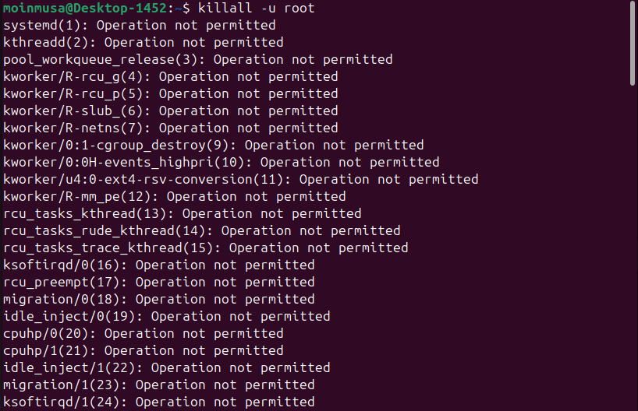

1. **Chmod & chown**

The "chmod" command modifies the read, write, and execute permissions of specified files and the search permissions of specified directories.



Giving access to a file:

Command: chmod +rwx filename to add permissions.

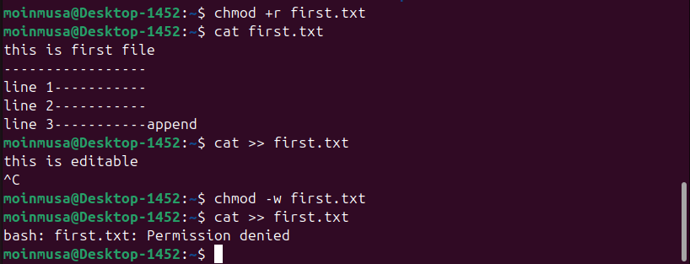

chown command is used to change the file Owner or group. Whenever you want to change ownership.

Changing the owner of a file or directory:

Command: chown -c owner name filename or directory

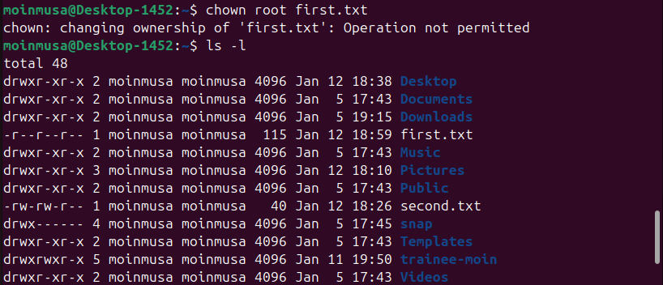

1. **apt**

The apt command in Linux is a high-level Command Line Interface (CLI) for the Advanced Package Tool (APT) package management system.



1. **apt-get**

The apt-get command is a command-line tool that helps manage software packages in Linux.

1. **History**

The history command in Linux provides a chronological list of previously executed commands

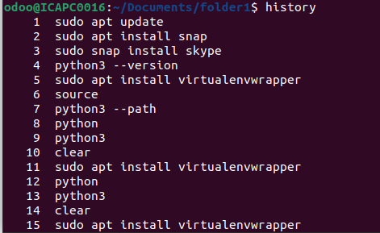

1. **nano**

Nano is a command-line text editor that comes pre-installed with most Linux distributions.

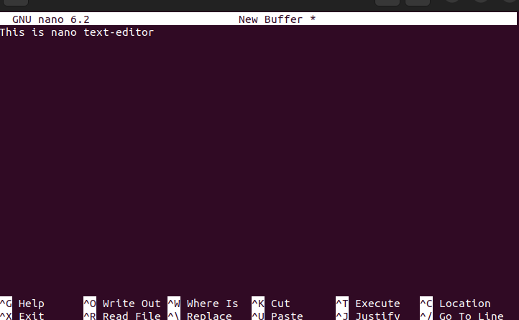

1. **Ifconfig**

The ifconfig command is a Linux tool that allows users to configure, query, and control network interface parameters

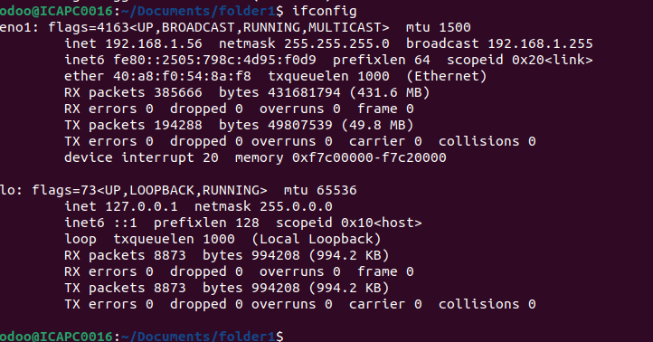

1. **ping**

The PING (Packet Internet Groper) command is used to check the network connectivity between the host and server/host.

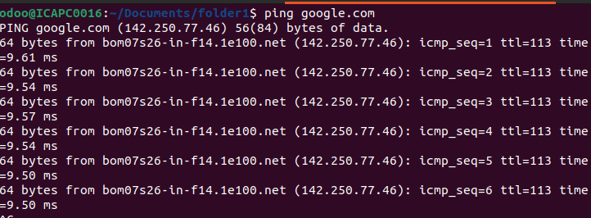

**Ubuntu Operators**

1. &

It is used to execute a command in the background without interrupting other commands. Processes/scripts/commands are sent into the background to execute other commands in the foreground. Script execution speeds up and the operator better utilizes system resources in shell script. Other programming languages refer to this as creating a child process or forking. Ampersands can be used in the following ways:

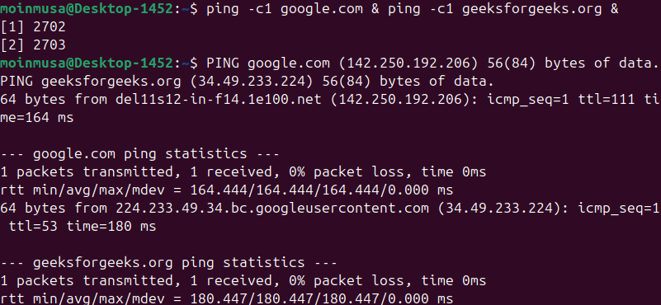

2. &&

A command following this operator will only be executed if the preceding command is successful. If the first command has been executed successfully, it is useful to execute another command after it has been successfully executed.



3. |

The output of the first command is sent to the input of the second command with this operator.



The wc -l command in the above command displays the number of lines. ls -l displays the lists the files in the system. This command displays how many files reside in the directory. The output of ls – l is passed to the next command, which counts the lines. As a result, we can find out the number of files in a directory by using pipe.

4. >,>>,<

Redirects the output of a command or a group of commands to a file or stream. the “>” is the output redirection operator used for overwriting files that already exist in the directory. While, the “>>” is an output operator as well, but, it appends the data of an existing file. Often, both of these operators are used together to modify files in Linux.

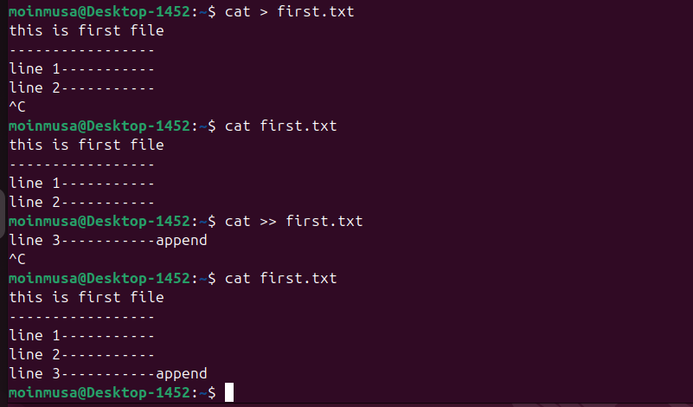

<: The < operator is used to redirect input from a file or another source to a command. It tells command to read input from the specified file instead of the standard input.

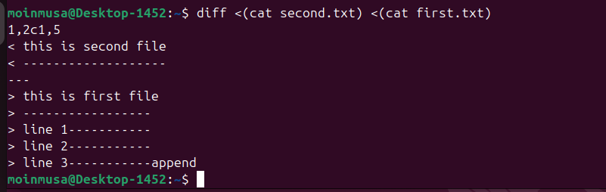

5. \

The backslash can escape spaces in file or directory names to prevent the shell from treating them as separate arguments. The backslash can escape single or double quotes to include them in a string.



6. *

represents the multiplication operator. For example:



7. ^

The ^ operator is used to math the beginning of a line or string in regular expression.

